

Mehran University of Engineering and Technology, Jamshoro.

Department of Computer Systems Engineering

**Web Engineering**

**(Assignment # 1)**

**Submitted on: 5th July 2021.**

Submitted by:

**Shahzain Ahmed (18CS86)**

Submitted to:

**Engr. Mahveer Rathi**

**Assignment # 1**

**1) Index.html: (Home)**

<!DOCTYPE html>

<html lang="en">

<head>

        <title>18CS86</title>

</head>

<body>

    <div style="text-align: center;"> <img src="MUETbanner.jpg" alt="MUET"> </div>

    <div style="text-align: center;">

    <a href="index.html">  <button>Home </a> </button>

    <a href="Water.html">  <button>Water Department </a> </button>

    <a href="Electrical.html">  <button>Electrical Engineering </a> </button>

    <a href="CSE.html">  <button>Computer Systems Engineering </a> </button>

    <a href="Library.html">  <button>Library </a> </button>

</div>

<br>

<div style="text-align: center;"> <h2> <u> Main Gate of Mehran University of Engineering and Technology Jamshoro </u> </h2></div>

<div style="text-align: center;"> <img src="maingate.jpg" alt="maingate"></div>

</body>

</html>



**2) Electrical.html:**

<!DOCTYPE html>

<html lang="en">

<head>

        <title>18CS86</title>

</head>

<body>

    <div style="text-align: center;"> <img src="MUETbanner.jpg" alt="MUET"> </div>

    <div style="text-align: center;">

    <a href="index.html">  <button>Home </a> </button>

    <a href="Water.html">  <button>Water Department </a> </button>

    <a href="Electrical.html">  <button>Electrical Engineering </a> </button>

    <a href="CSE.html">  <button>Computer Systems Engineering </a> </button>

    <a href="Library.html">  <button>Library </a> </button>

</div>

<br>

<div style="text-align: center;"> <h2> <u> Department of Electrical Engineering </u> </h2></div>

<div style="text-align: center;"> <img src="electrical.jpg" alt="electrical"></div>

</body>

</html>



**3) Library.html:**

<!DOCTYPE html>

<html lang="en">

<head>

        <title>18CS86</title>

</head>

<body>

    <div style="text-align: center;"> <img src="MUETbanner.jpg" alt="MUET"> </div>

    <div style="text-align: center;">

    <a href="index.html">  <button>Home </a> </button>

    <a href="Water.html">  <button>Water Department </a> </button>

    <a href="Electrical.html">  <button>Electrical Engineering </a> </button>

    <a href="CSE.html">  <button>Computer Systems Engineering </a> </button>

    <a href="Library.html">  <button>Library </a> </button>

</div>

<br>

<div style="text-align: center;"> <h2> <u> Central Library </u> </h2></div>

<div style="text-align: center;"> <img src="library.jpg" alt="library"></div>

</body>

</html>

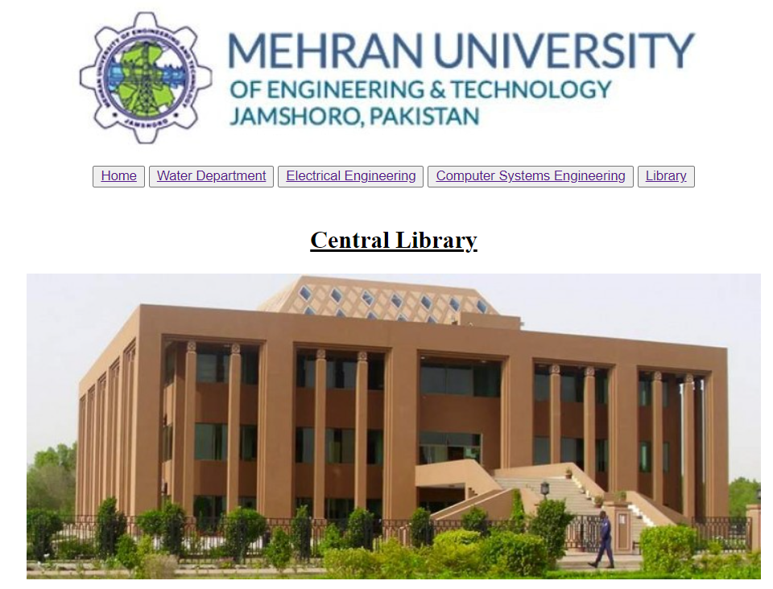

**4) Water.html:**

<!DOCTYPE html>

<html lang="en">

<head>

        <title>18CS86</title>

</head>

<body>

    <div style="text-align: center;"> <img src="MUETbanner.jpg" alt="MUET"> </div>

    <div style="text-align: center;">

    <a href="index.html">  <button>Home </a> </button>

    <a href="Water.html">  <button>Water Department </a> </button>

    <a href="Electrical.html">  <button>Electrical Engineering </a> </button>

    <a href="CSE.html">  <button>Computer Systems Engineering </a> </button>

    <a href="Library.html">  <button>Library </a> </button>

</div>

<br>

<div style="text-align: center;"> <h2> <u> U.S.-Pakistan Center for Advanced Studies in Water</u> </h2></div>

<div style="text-align: center;"> <img src="water.jpg" alt="water"></div>

</body>

</html>

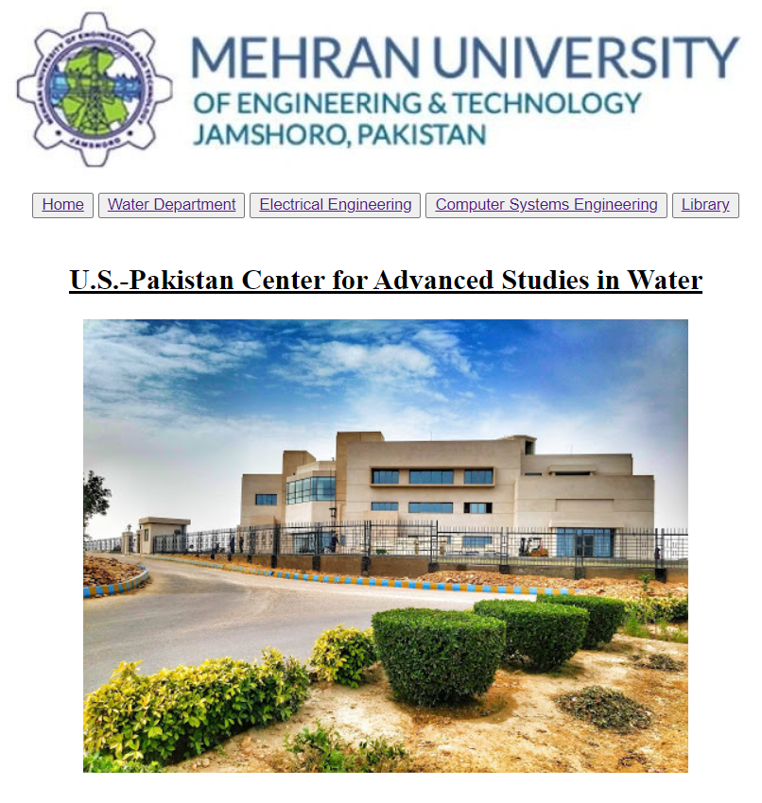

**5) CSE.html:**

<!DOCTYPE html>

<html lang="en">

<head>

        <title>18CS86</title>

</head>

<body>

    <div style="text-align: center;"> <img src="MUETbanner.jpg" alt="MUET"> </div>

    <div style="text-align: center;">

    <a href="index.html">  <button>Home </a> </button>

    <a href="Water.html">  <button>Water Department </a> </button>

    <a href="Electrical.html">  <button>Electrical Engineering </a> </button>

    <a href="CSE.html">  <button>Computer Systems Engineering </a> </button>

    <a href="Library.html">  <button>Library </a> </button>

</div>

<br>

<div style="text-align: center;"> <h2> <u> Department of Computer Systems Engineering </u> </h2></div>

<div style="text-align: center;"> <img src="CSE.jpg" alt="cse"></div>

</body>

</html>

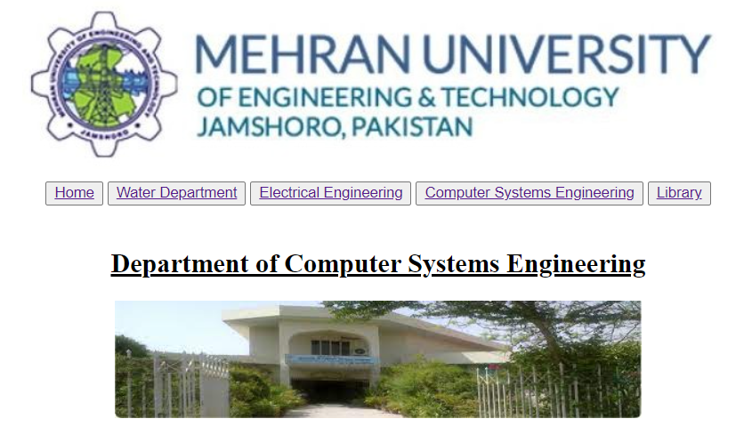

**Task Given:**

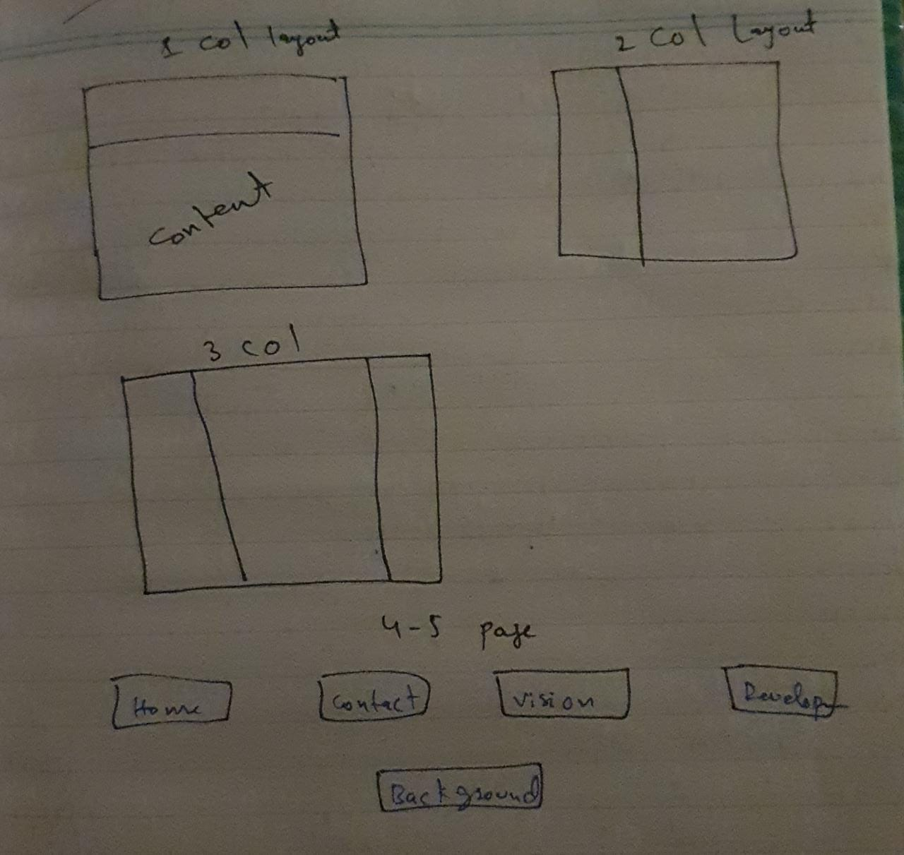

**Hosted Website Link:**

[**https://shahzainahmed.github.io/MUETWebsiteTask/**](https://shahzainahmed.github.io/MUETWebsiteTask/)